Bid 353
Northland Park Building 1 Mass Grading & Building 1 Pad Port KC Questions 9-9-16

1). There are two RFP's for this project. One from Port KC and one from NorthPoint. There are items in each which contradict the other. For example, the Port KC RFP implies this will be a prevailing wage project
and refers to a wage order. However, item 6 on page 2 of the NorthPoint RFP says, "Prevailing wage is not
required for private mass grading and construction of the building pad." Which RFP take precedence over the other? Is the project a prevailing wage project? NORTHPOINT RFP TAKES PRECEDENCE.
2). If the project is a prevailing wage project, please provide Wage order referred in the Port KC RFP? N/A
3). The Port KC RFP says the company will be required to comply with Port KC's affirmative action policy.
Is there a set MBE and WBE usage % for the project? INFO PROVIDED IN PORT KC EXHIBITS. POLICY FOUND HERE. THE CONSTRUCTION WORKFORCE AFFIDAVIT CAN BE FOUND HERE.

4). The anticipated construction date listed in the NorthPoint RFP is Sept 26, 2016 Is this a realistic date for when we can plan to start the work or just an estimated date? THIS IS THE ESTIMATED DATE. WORK WILL COMMENCE UPON RECEIPT OF PERMIT FROM KCMO. WE ANTICIPATE RECEIPT OF PERMIT APPROVAL BY 09-26-16.

5). Do I understand correctly, we are simply doing the mass grading of the site including the grading of the building pad and the installation and removal of a dirt surcharge on the building pad, is that correct? CORRECT
We do not include sub-grading for curbs, pavements and sidewalks, is that correct? CORRECT
We do not include site finishing grading once the building is constructed, is that correct? CORRECT
Once the surcharge is removed, the detention ponds are constructed, we would be complete with our contractual requirements, is that correct? CORRECT

6). Paragraph 1.1.A.3 of the NorthPoint RFP says, "The scope of design work to be furnished by the Contractor shall included additional design, if any, necessary to provide a complete turnkey scope of construction work." What design work would we have to provide? NO ADDITIONAL DESIGN WORK IS ANTICIPATED

7). Will an addendum be issued removing the requirements of paragraph 1.5 of the NorthPoint RFP since the mass grading work design is suppose to be 100% complete? ADDITIONAL DESIGN WORK IS NOT ANTICIPATED

8). Is the intent of the drawings and scope of work that the site be a balanced site condition such that all material necessary for construction, including the building surcharge be obtained from the site and no fill material will have to be hauled in or excavated material haul out of the project? THE INTENT IS FOR A BALANCED SITE – ANY EXCESS MATERIAL IS TO BE LEFT ONSITE FOR USE IN FUTURE BUILDING PAD CONSTRUCTION – ANY ADDITIONAL MATERIAL REQUIRED TO BRING THE SITE TO GRADE OR TO COMPENSATE FOR SHRINKAGE OR CONSILIDATION IS THE RESPONSIBILTY OF THE CONTRACTOR

9). Paragraph 2.4 of the NorthPoint RFP says for the Contractor to include any retaining walls or slope reinforcement needed to achieve the grades and critical elevations shown on the plan. Is this a requirement for the next contractor or will the mass grading contractor have to plan on the construction of retaining walls? If so where at? RETAINING WALLS ARE NOT ANTICPATED TO BE REQUIRED FOR THE MASS GRADING SCOPE OF WORK.

10). Paragraph 2.5 of the NorthPoint RFP discussed temporary parking, storage and haul roads. Is this requirement only for our work or it is suppose to include the building contractor's work? We will
not need any temporary rocked areas other than the construction entrance. Are there any rocked areas you want us to included in our proposal? If so, how big of an area, how thick and type of rock. THIS NOTE IF FOR THIS SCOPE OF WORK ONLY. PROVIDE AS SHOWN ON THE DRAWINGS. CONSTRUCITON ENTRANCE TO REMAIN UPON COMPLETION OF WORK.

11). Your minimum insurance requirement has umbrella excess liability of $10,000,000 aggregate. Does the grading contractor need this much of a limit or can it be less? PROVIDE PROPOSED INSURANCE TERMS IN RFP RESPONSE.

12). What is the anticipated date of the Corps of Engineers Permit to allow entrance into the Agricultural Wetlands? Is there any work that is suppose to take place in the two Agricultural wetlands? They appear in all the plan sheets to surrounded by silt fence and left alone, is that correct? ANTICIPATED DATE OF CORPS APPROVAL IS 10/07. THE LARGER OF THE TWO AREAS IS WITHIN THE GRADING AREA. THE SMALLER OF THE TWO IS INTENDED TO BE LEFT ALONE. SILT FENCE AROUND THIS AREA TO REMAIN AT COMPLETION OF WORK.

13). Do we include all of the ECS Phase 4 ground cover work as shown on sheet C105? There is work, for example, the Rip-Rap Flumes that would appear to be installed after the parking lots are installed which leads me to believe we will be on site until the building is completed, is that correct? RIP RAP FOR FLUMES ARE ALL INTENDED TO BE FUTURE AND PART OF THE BUILDING PACKAGE. EXCLUDE ANY WORK THAT WILL NOT BE PERFORMED SEQUENTIALLY OR CONCURRENTLY WITH THE MASS GRADING AND SURCHARGE.

14). Can the sediment basin clay liner be installed during the construction of the basins or does it need to be installed at the end of the project cycle? CLAY LINER CAN BE INSTALLED DURING CONSTRUCITON OF THE BASINS. IT WILL NEED TO BE MAINTAINED DURING THE REMAINDER OF THE GRADING WORK UNTIL THE SITE IS TURNED OVER TO THE GENERAL CONTRACTOR.

15). Please provide exhibits A, B, & C as referenced in the Port KC RFP along with the bid form. PROVIDED BY PORT KC.

16). In the Port KC RFP there is a reference to a Scope of Work Statement. Is this something that will be coming or is it just referring to the plans and specs. as the scope of work. IT IS REFERENCING THE PLANS AND SPECS.

17). When silt is removed from the basins, can it be left on site or does it need to be hauled off site? SILT CAN REMAIN ONSITE NEAR THE TOPSOIL STOCKPILE AREA.

18). It is ok if we go to the site and dig a couple of test holes to examine the dirt we will be excavating? We will compact back the material removed and will keep out of the wet lands. We want to do this Monday or Tuesday of next week. Yes. Site is not restricted. Proceed at your convenience.

19). Is it the intent to do any grading work on Lots 2 & 3 other than grading the ditches along the existing roadways and the borrow for the surcharge? The proposed contours do not tie in to the existing contours but I am not sure it is unclear if we need to make fills on these lots or just do the ditch grading. Yes, mass grading is for the entire site. ****Clarification to response 19: Erosion control measures and storm channels/ditches as shown on the drawings is the only scope of work for lots 2 & 3.

20.)
21.)

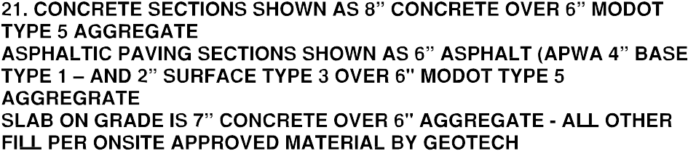

22.) The answer to Question 8 in the Q&A appears to contradict itself. The first part of the answer says “The intent is for a balanced site” and the last part of the answer says “Any additional material required to bring the site to grade or to compensate for shrinkage or consolidation is the responsibility of the contractor”. The first part of the answer indicates we will balance the site which means no import or export of material from the site. The last part of the answer seems to indicate if the project is short of material we will be required to import material from off-site to complete. Can you please clarify which part of this answer will be required? Ultimately the contractor is responsible for delivering the site at the elevations shown on the grading plans.

23.)
24.) 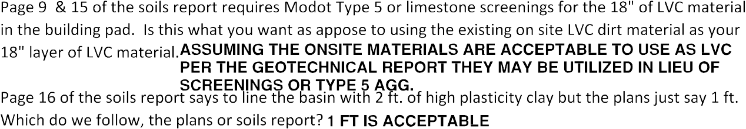

25.) Are we allowed to contact Northpoint directly to answer a question? SUBMIT ALL QUESTIONS TO info@portkc.com

26.) The Northpoint RFP and bid form require Builder’s Risk Insurance for this project. As this project is a mass grading project and we are not constructing any structures, this additional cost for insurance seems unnecessary. Can the requirement for Builder’s Risk Insurance be deleted from this contract? Yes, but please provide as an add alternate.

27.) After reviewing the previous questions and answers for this project there seems to be several contradictions between Port KC’s and Northpoint’s intent. Are we to provide a bid bond and in the event of award a performance and payment bond? Yes. Bid bonds with the bid and if the contract is awarded Port KC is bound by statute to require a payment bond (for projects above $50k) and Port KC also require a performance bond.

28.) Do we leave the site graded to the contours shown on the plans or to pavement sub-grade elevations? GRADE TO THE CONTOURS SHOWN ON THE PLANS.

29.) Who’s name do we use as the owner for the Bid Bond? Northpoint Development or Port KC? For the bid bond – NorthPoint with Port KC as additional. For the payment and performance bond (if awarded the contract) – Port KC

30.) Are we required to carry Professional Liability insurance for this bid package? NO

