South Loop Project Hits Major Funding Milestone
$45 Million Raised in Private Funds toward Proposed Green Space Project

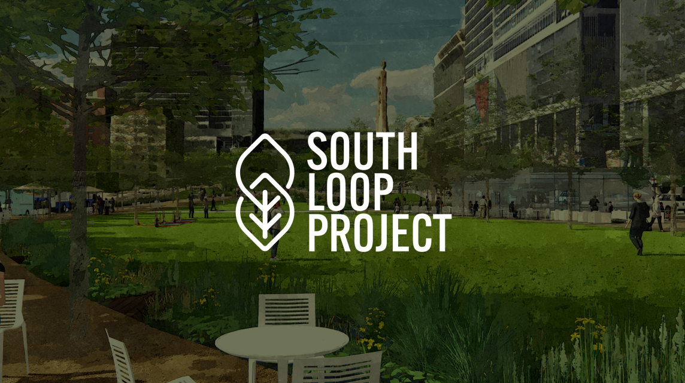

For immediate release: February 24, 2023

The South Loop project is moving forward thanks to $45 million dollars in fundraising efforts. This funding is made possible thanks to donations from H&R Block Inc., federal funding secured by Retired U.S. Senator Roy Blunt, and private donations from JE Dunn Construction Co., Loews Kansas City Hotel, Kansas City Southern, Power & Light District, the Cordish Companies, and 1400 Baltimore.

H&R Block Inc., in partnership with the Marion and Henry Bloch Family Foundation and the H&R Block Foundation, committed a lead gift of $10 million toward the South Loop Project, a sustainable park in the heart of downtown Kansas City. The pledge marks the largest private donation so far to the proposed green space project.

“Today, I am proud to announce we reached a major milestone toward making the South Loop project a reality, thanks to H&R Block’s generous contribution. We are proud to continue to partner with our federal, state, and local private businesses to make this project happen, improving the quality of life for residents and businesses in the area,” Mayor Quinton Lucas said. “I think about how downtown has changed over the last generation, many of us remember sometimes the loud bulls out on the streets. Some of us remember seeing nothing but surface parking lots and feel like and we have seen great improvement today. Downtown is a place for everyone around our region to enjoy, as we saw from the Chiefs Parade the other day, and importantly will be a place that we continue to build outstanding public spaces that are modeled not only for the region, but the entire country.”

“The South Loop Project represents a rare opportunity to reshape Downtown Kansas City by creating a public gathering space for the region and a new destination attraction that will positively impact our entire community,” said Bill Dietrich, President & CEO of the Downtown Council of Kansas City. “We are profoundly grateful to H&R Block, the Bloch Family Foundation, and the H&R Block Foundation for embracing this state-of-the-art destination park.”

The South Loop will be a catalytic public gathering space, designed as a full sensory experience for park-goers of all ages. The proposed 4.6-acre park features whimsical gardens, accessible play spaces, public entertainment forums, pop-up markets with local businesses, year-round programming and more.

“When you travel across America and around the world, you realize the great cities have breathtaking urban parks,” said Jeff Jones, H&R Block President and Chief Executive Officer. “Our commitment to this project is a reflection of our work to Make Every Block Better, our belief in Kansas City, and our collective ambition of greatness.”

Founded in 1955, H&R Block opened its world headquarters nearly 17 years ago at 13th & Main in Downtown, just a short walk from the planned South Loop Project. In 2019, the company launched its community impact platform, Make Every Block Better, which is focused on increasing connections by improving the places and spaces where neighbors convene.

“We are thrilled to join H&R Block in making this leadership gift,” said David Miles, President, H&R Block Foundation and the Bloch Family Foundation. “We believe the South Loop Project represents the Bloch family’s long-standing commitment to bring together diverse individuals and families to share experiences.”

The $200 million South Loop Project is a collaborative effort led by the City of Kansas City, the Downtown Council, and Port KC. The South Loop is a catalytic project priority of the Imagine Downtown KC 2030 Strategic Plan, developed by the community under the leadership of the Downtown Council and the City of Kansas City.

Taking inspiration from urban parks such as Dallas’ Klyde Warren Park, the South Loop Project creates a more sustainable downtown by improving air quality, reducing noise, implementing a green infrastructure and achieving LEED benchmarks, with a commitment to prioritize pedestrians, cyclists and multimodal transportation.

“We know today, without a doubt, the importance of nature to the health of the human race. This project will change the lives of those who call KC’s Downtown and Midtown home,” said Jon Stephens, President & CEO, Port KC. “It’ll impress upon the millions of visitors the value our leaders place upon our built environment for all. The South Loop Project also shows the power of collaboration. These Kansas City anchors’ generosity will benefit ALL who live here.”

Project leaders are working to create a final design commencing in the first quarter of 2024 with construction activities beginning shortly thereafter.

“Our primary goal is to complete construction of the South Loop by the end of the first quarter of 2026, so the park can be opened and used by the public for the World Cup event that will take place in June that year,” Dietrich said.

The leadership team expects to fund the design and construction of the estimated $200 million project through public-private partnerships that will include federal, state, local, and private funding, including $28.6 million in federal funding that has been secured through the efforts of retired U.S. Sen. Roy Blunt, as well as the $10 million private commitment announced today and $8 million in other private contributions with the goal of completing construction in time for the park to be used by the public during the FIFA World Cup in Kansas City and other North American locations.

“Today’s announcement is a tremendous expression of confidence in the vision and reality of the South Loop urban green space,” Dietrich said.

An open house is planned for Tuesday, March 7, from 4:30-6:30 p.m. at the Kirk Family YMCA, 222 W 11th Street, Kansas City, MO 64105. The public is invited to attend to learn more about the South Loop Project and to share ideas with the planning team. For further information visit kcsouthloopproject.org.

###
Media with questions may contact Sherae Honeycutt, Press Secretary for Kansas City at Sherae.Honeycutt@kcmo.org or (816) 946-3611.

